| **Test Name** | | Successful login | | | |
| --- | --- | --- | --- | --- | --- |
| **Use Case Tested:** | | Use Case 13 – Log in | | | |
| **Test Description:** | | User wishes to enter an error.  User enters a valid username.  User enters a valid password that relates to the username.  User selects Submit button.  User is presented with the Enter an Error page. | | | |
| **Pre-conditions** | | A valid user name and password exists for user | | | |
| **Post-conditions** | | Enter an Error page is presented to user for completion  User will only have Log Out option available in the menu bar | | | |
| **Notes:** | | *Screenshots relating to test can be found after the Test Data Table* | | | |
| **Result (Pass/Fail/Warning/Incomplete)** | |  | | | |
|  | **TEST STEP** | | **EXPECTED TEST RESULTS** | P | F |
|  | User enters valid username | | No error appears | P |  |
|  | User enters valid password that relates to username | | No error appears | P |  |
|  | User selects Submit button | | Enter an Error page appears | P |  |

|  |  |  |  |  |  |
| --- | --- | --- | --- | --- | --- |
| **Test Data Table** | | | | | |
|  | **1** | **2** | **3** | **4** | **5** |
| Valid Username: | test@test.com | jules@test.com | frank@test.com |  |  |
| Valid Password: | 12345678 | password | 87654321 |  |  |
|  |  |  |  |  |  |

SCREENSHOTS RELATING TO TEST

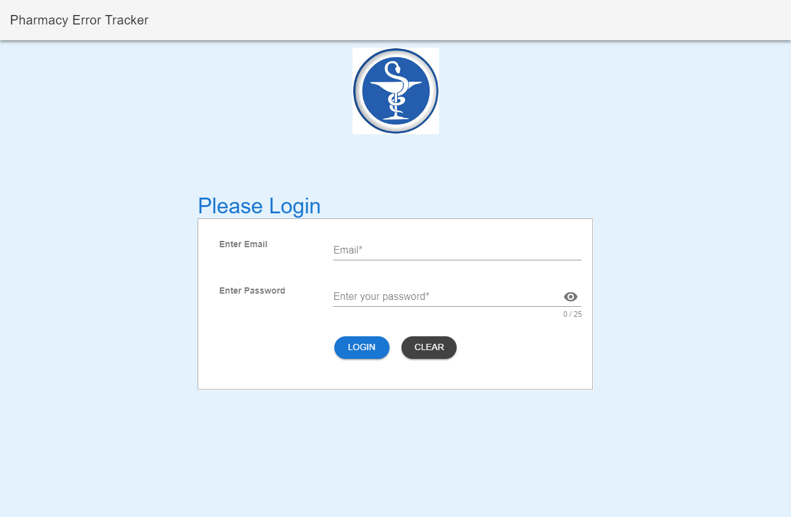

Test1: Initial login page displayed to the user

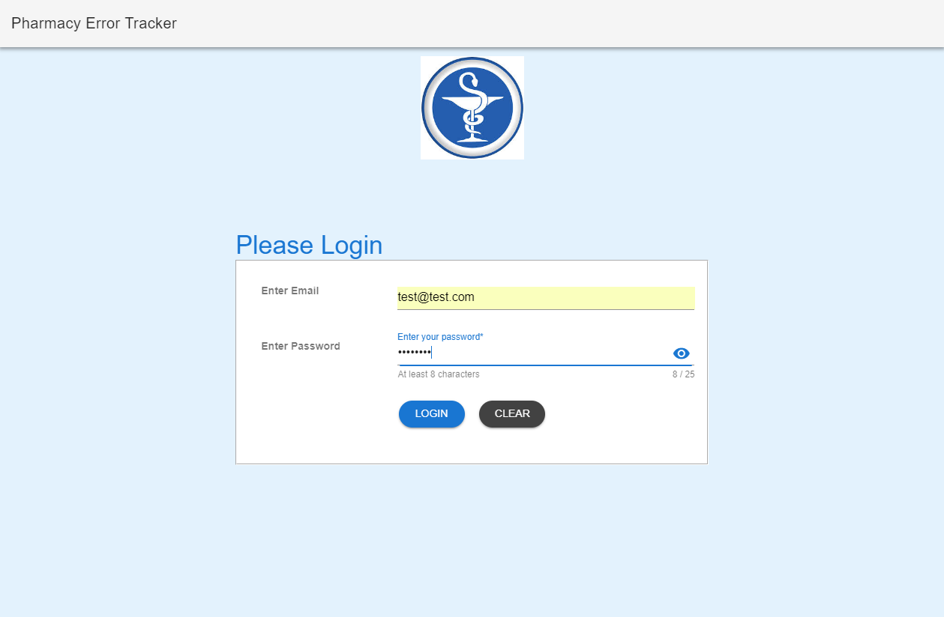

Test 1: User [test@test.com](mailto:test@test.com) email and password entered into the login screen

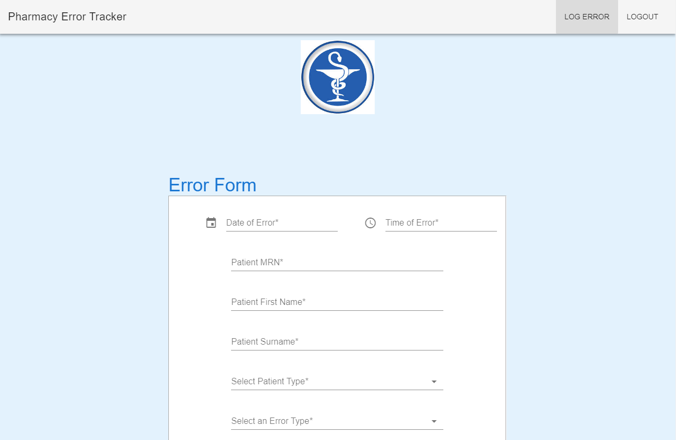

Test 1: Error Form displayed after successful login of user.



Test 2: Initial login page displayed to the user

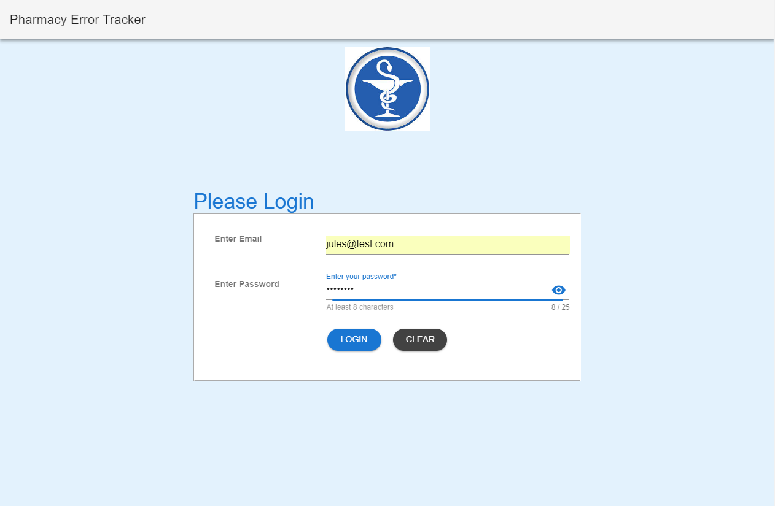

Test 2: User [jules@test.com](mailto:jules@test.com) email and password entered into the login screen



Test 2: Error Form displayed after successful login of user.



Test 3: Initial login page displayed to the user

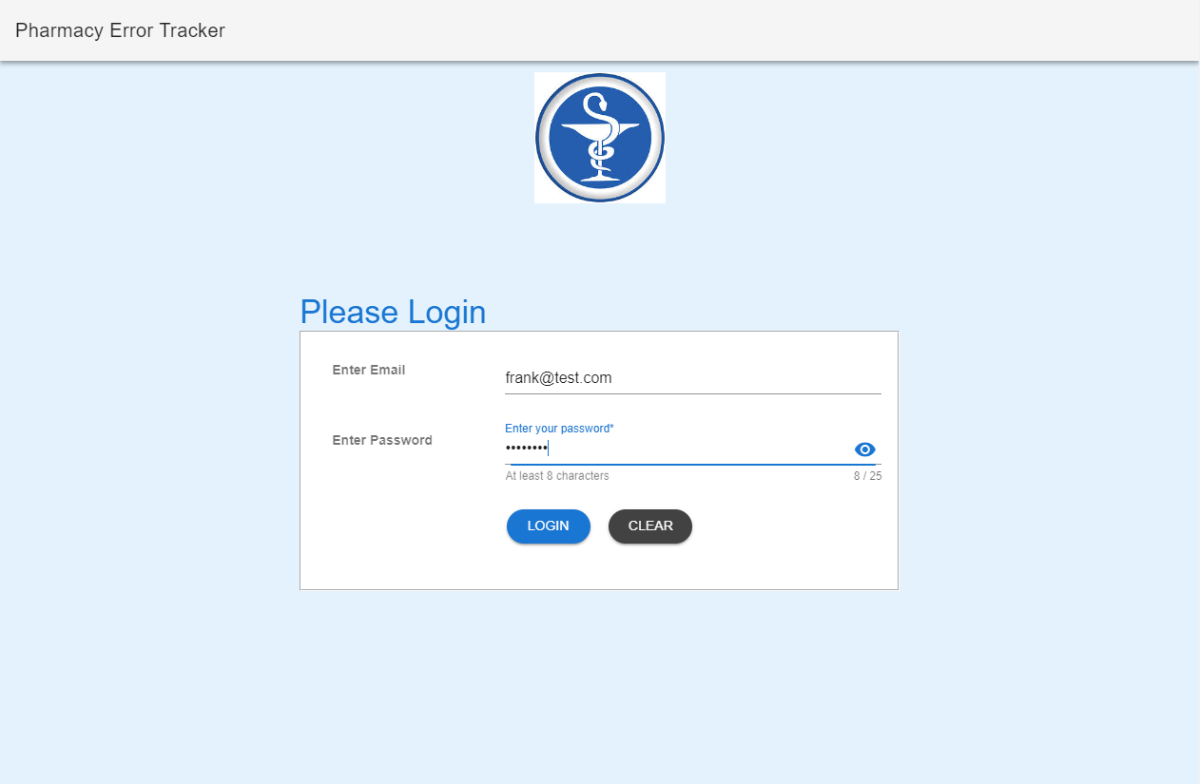

Test 3: User [frank@test.com](mailto:frank@test.com) email and password entered into the login screen



Test 3: Error Form displayed after successful login of user.